ANR Scoring and Visualisation software: generate and import ANR routes (parcours) with Google Earth

Table of Contents

1. Introduction 1

2. Define route center lines in Google Earth Pro 2

3. Generate ANR routes (parcours) 4

4. Adjust PROH areas in Google Earth 5

5. Importing the kml file as Parcours into the ANR Scoring & Visualisation software 6

## Introduction

The official Air Navigation Race Scoring & Visualisation Software (see picture below) allows to import georeferenced map data and create ANR competition routes (parcours) which can then be used in ANR competitions.

## Define route center lines in Google Earth Pro

-Open Google Earth Pro (note despite of the name, this version is available/downloadable at no cost)

-Start defining one or several **route center lines** (using the 'Path' function in Google Earth) 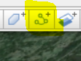

-For each route, the first point is the starting point, the last point the end point. **Ensure that the route orientation (start to end) is identical for all routes.**

-Adjust the location and length of the center lines (check the length in NM / meters etc.) as required: In Google Earth, select the Center line path (in the left window), press the right mouse button, and select “**Properties**”. Then select the tab “Measurements” and check the length of the path.

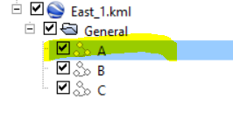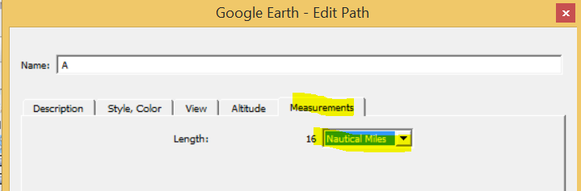

-Naming of the route center lines in Google Earth: name the center lines just “A”, “B”, “C”. Rearrange the route center lines so that A will be the first, B the second etc. The leftmost center line (seen from start towards end point) should be route A.

-Save the file as *.kml file (not *.kmz).

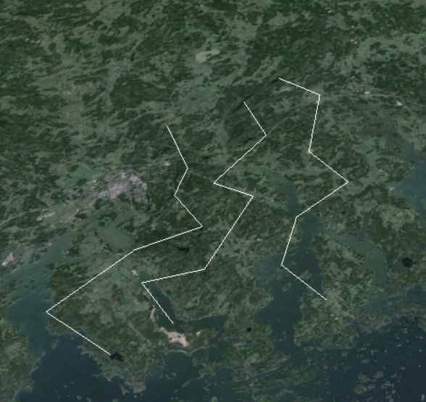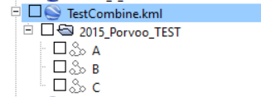

Example: three route center lines with identical length. The route direction is approximately north to south. In this case, the leftmost route A (seen from starting point) is the eastern route.

**IMPORTANT NOTE: for the route center lines (“channels”), use only the characters A, B, C, or D as names. Do not use any other names!** Reason: the parcour import in the *ANR Scoring & Visualization software* (later on in this document) expects these fixed names. The parcour import will be successful, but later on (after importing the logger data), the penalty point calculation will not succeed (the flight track will be shown, but calculation always zero penalty points)

## Generate ANR routes (parcours)

- Open the ANR application, select **“Tools…”- “Route Generator**”.

-On the Route generator, select “**Open *.kml route file…**” and open the kml file that you saved in the previous step.

-Adjust parameters as required (channel width and Height AGL)

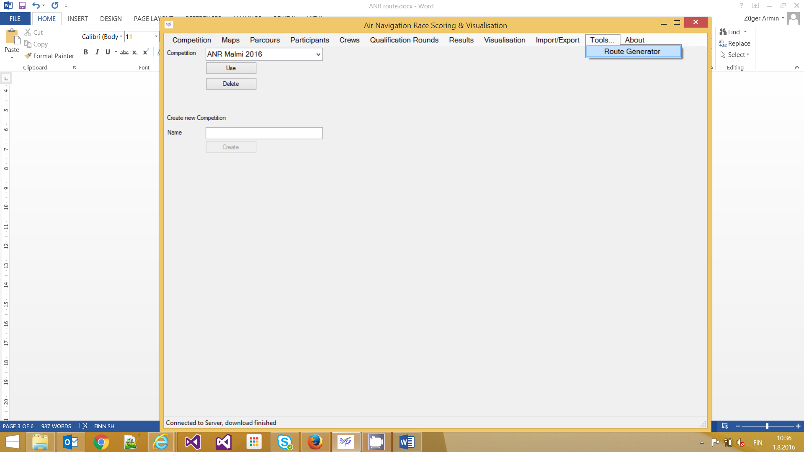

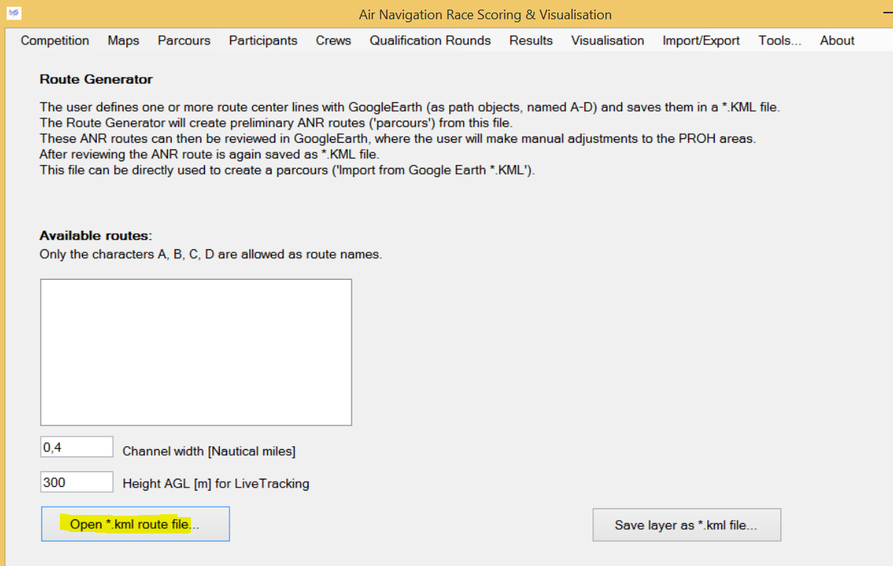

-The application lists all available route center lines

-Select one or several route center lines for which you want to generate full-blown ANR routes. Usually you want to select all so keep the checkbox “Add all routes to selected” and press “Add to selected”. T

-Pressing “**Save layer as *.kml file…”** will start the generation process and create an output kml file.

-The red prohibited areas which are forming the “channels” will be estimated and calculated (they will be manually modified later on manually).

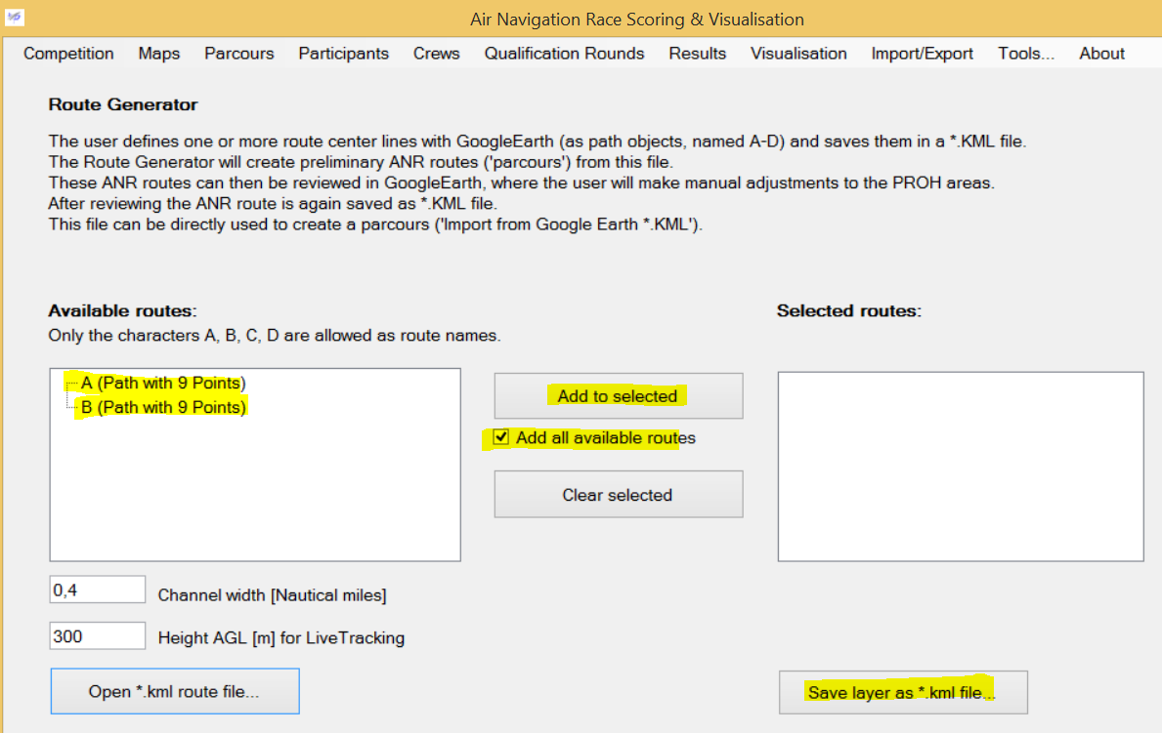

## Adjust PROH areas in Google Earth

-Open the generated kml file and inspect the results

-The results are arranged in two folders; ‘General’ and ‘LiveTracking’.

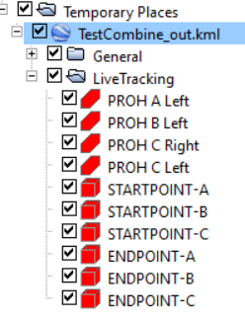 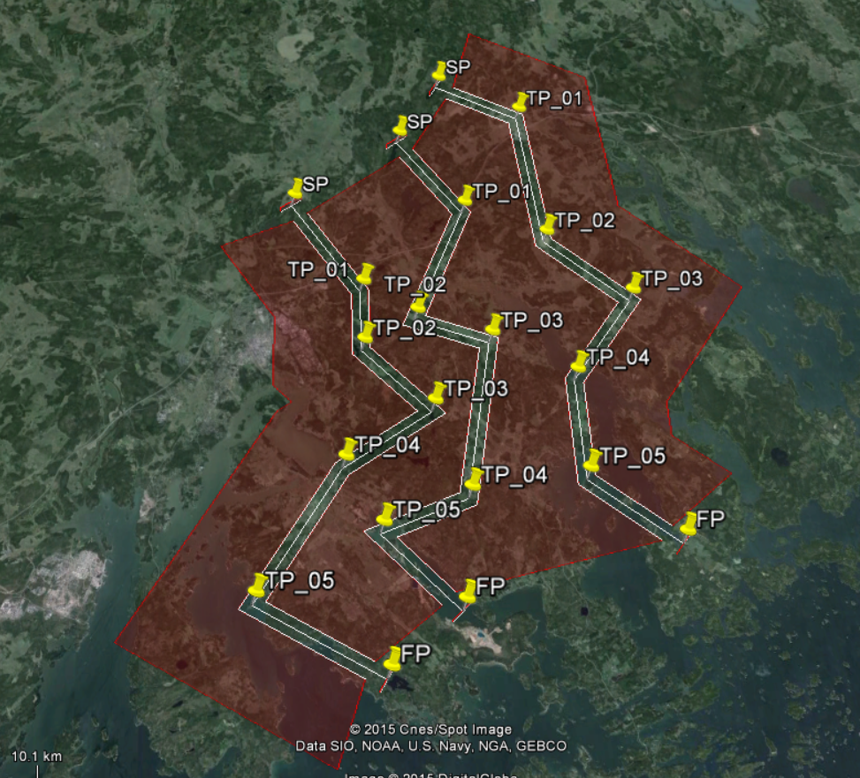

-Usually some modifications on the PROH areas are required. These areas are located in the ‘LiveTracking’ folder. If required, edit the areas in Google Earth, then save again as *.kml file.

Editing Polygons: In Google Earth, select the polygon in the right hand panel, press the reight mouse button and select “**Properties**”. This will highlight the selected polygon in the main window, where you can modify now the points (see picture below).

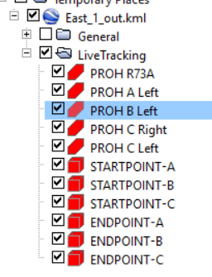 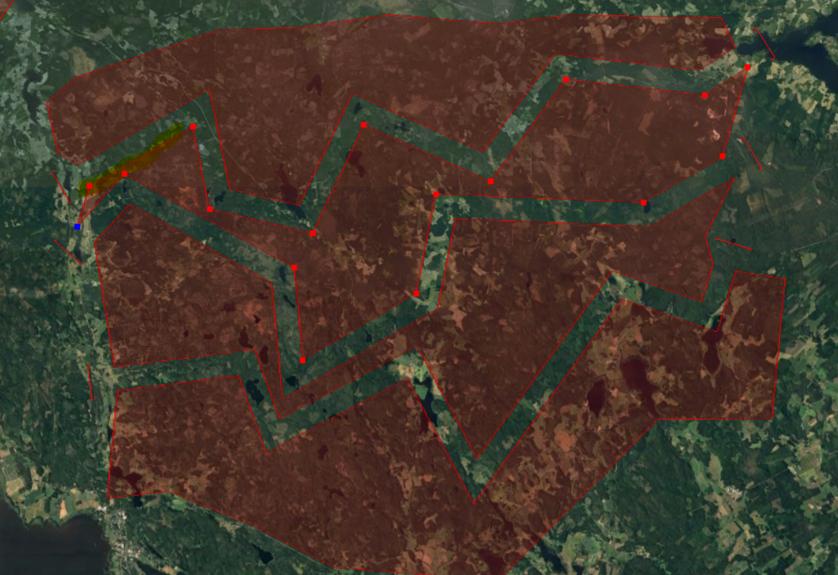

**NOTE**: if required, you may also include additional areas (e.g. Danger-, or Restriction areas, control zones etc.) into the *.kml file; they will be displayed also on the competition map. The only naming convention is that the name of the area must start with “PROH“(e.g. “PROH R73A”).

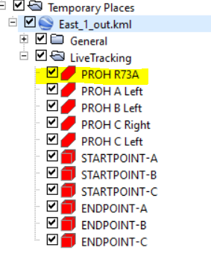

**NOTE: in the kml file, do not change the folder named “LiveTracking”.** The application expects valid data in this folder.

-Save / replace the existing kml file.

**This modified file can be directly imported into the ANR Visualization & Scoring software (see next step)**. The entire content of the ‘Livetracking’ folder can also be used as *.kml file for Real-time visualiszation in other applications (LiveTrack24.com, WAY.Aero etc.).

## Importing the kml file as Parcours into the ANR Scoring & Visualisation software

The following description assumes that you already have imported a map for the competition area.

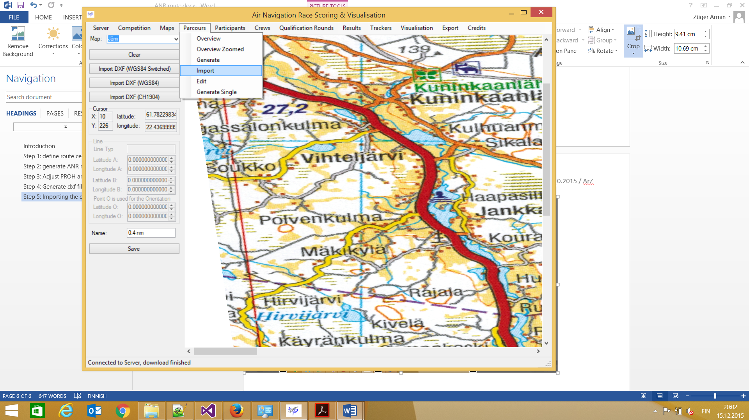 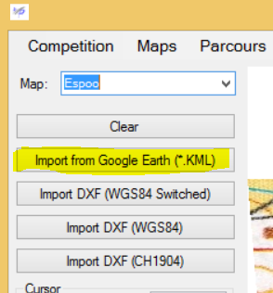

Select **Parcours-Import,** then select the map from the dropdown list on the upper left corner.

Then select **Import from Google Earth (*.KML)** and load the *.kml file that you created in step 3.

Now you should already see the corridors and prohibited areas as an overlay on the map picture. Name the parcours and save it.

**Problems**:

* **No red prohibited areas visible, no error messages:**

-on the map definition (Maps-Import from Worldfile, then select the required map), verify that the coordinates are correct.

-verify that the decimal separator in the world file is correct (either dot or decimal, no thousand separator)

* **Scoring problems: Importing of logger result is OK, the flown track is displayed, but the penalty point calculation does not work**

-check the parcours in the ANR Scoring and visualization software. Start- and Endpoint must show the red circle & line (see picture below) (however note that this red circle is not shown on the exported pdf file, but only in the scoring software itself). A missing circle usually means the name of the start- or endpoint is incorrect.

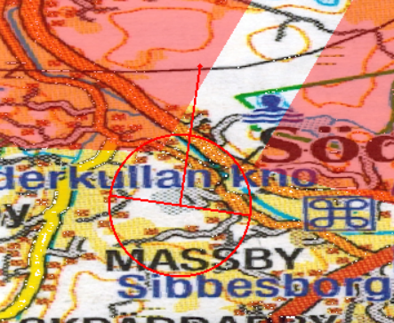

* -Verify that the polygon naming in the kml file is correct: in the folder “LiveTracking”. Only the following names are considered
* “STARTPOINT-A” to “STARTPOINT-D”
* “ENDPOINT-A” to “ENDPOINT-D”
* All Polygons that have a name starting with “PROH “.